GSM GSM 10.56
Permanent 2000 - 03
Document Version 8.0.0
Source: Work item rapporteur : Michel Galligo ( Alcatel )
Key words: Digital cellular telecommunications system, Global System for Mobile communications (GSM)



Digital cellular telecommunications system (Phase 2+);
Project scheduling and open issues:
GSM Cordless Telephony System CTS, Phase 1
(GSM 10.56 version 8.0.0)

European Telecommunications Standards Institute
ETSI PT SMG Secretariat
Postal address: F-06921 Sophia Antipolis CEDEX - FRANCE
Office address: 650 Route des Lucioles - Sophia Antipolis - Valbonne - FRANCE

Tel.: +33 492 94 42 66 - Fax: +33 493 65 28 17

Contents
1. Scope
1.1 References
2. General Considerations for CTS phase 1:
2.1 Decisions at SMG
2.1.1 SMG#21:
2.1.2 SMG#22
2.1.3 SMG#23
2.1.4 SMG#24
2.1.5 SMG#25
2.2 Decisions on CTS Service Requirements
2.3 Decisions on CTS stage 2
2.4 Funding of CTS security algorithms
2.5 Co-operation with ETSI TC-ERM:
2.6 Support tools for specification work
2.7 Work item rapporteurs based on the WID
3. Deliverables on CTS, phase 1
3.1 New specifications
3.2 CR’s to existing specifications
4. Project Plan for CTS phase 1
4.1 Scope of SMG meetings on CTS phase 1
4.2 Major Milestones for CTS phase 1
4.3 CTS stage 1 requirements for later phases of CTS (according to [1])
4.4 CTS stage 2 definition
4.5 Involved SMG STC’s
4.6 CTS phase 1 overall schedule
4.7 CTS phase 1 schedule from SMG#26to SMG#27
4.7.1 CTS stage 1
4.7.2 CTS stage 2
4.7.3 CTS stage 3
4.7.4 CTS stage 3
5. History

Scope
The purpose of this document is to describe the schedules of the GSM Cordless Telephony System (CTS) standardisation process for its first phase. This document is also meant to describe open issues that are under discussion and the relevant technical decisions which are taken during the specification process. A comprehensive project plan forms the integral part of this document in chapter 4 (including a list of meetings relevant for CTS, Milestones, a list of open issues and an overall schedule)
This document is a ‘living document’ and permanently updated. Proposals for change shall be forwarded to the responsible rapporteur. The CTS specification rapporteurs should make sure that this document can always reflect the latest status of work.
This document has been introduced at the late phase of CTS phase 1, stage 1. During this definition phase several STCs besides SMG1 have already been involved (SMG2, SMG12, SMG10), however from stage 2 definition on a documented co-ordination of the standardisation seems to be essential as the work item is or soon will be handled in almost every SMG STC (see chapter 2.6).
The summary of the CTS work item progress since the introduction of CTS ad SMG#21 is reflected in chapter 2.

References
[1] Draft GSM 02.56: “Digital cellular telecommunications system (Phase 2+);
GSM Cordless Telephony System (CTS), Phase 1; Service Description; Stage 1”,
[2] Draft GSM 03.20 Annex E: ”Digital cellular telecommunication system (Phase 2+);
GSM Cordless Telephony System (CTS), Phase 1, Security related network functions; stage 2;
[3] Draft GSM 03.56: “Digital cellular telecommunications system (Phase 2+);
GSM Cordless Telephony System (CTS), Phase 1; Service Description; Stage 2”,

General Considerations for CTS phase 1:

Decisions at SMG

SMG#21:
1. A work item proposal “GSM COMPATIBLE HOME BASE SYSTEM” is presented at SMG#21 (Tdoc 88/97).
2. It is decided, that the matter is studied by SMG 1, SMG 2, SMG 3, SMG 9 and SMG 10 and to report at
SMG #22. SMG 1 should co-ordinate the feasibility study (Tdoc 287/97).

SMG#22
1. The concept has been considered to be feasible. The feasibility study report and updated WID has been presented (Tdoc 382/97).
2. The work item is approved at SMG#22. The title is “GSM - Cordless Telephony System (CTS)”

SMG#23
1. The CTS work item status and schedule is presented (Tdoc 811/97)
2. The following working assumptions are taken by SMG#23 in order to proceed on the stage 1 work:
- operation of CTS is tied to a GSM subscription
- CTS is to operate in the spectrum of the home network of that subscription
3. The working assumption of SMG7, that both the CTS mobile station and the CTS fixed part should be considered as terminals, was confirmed by SMG#23

SMG#24
Only UMTS and release 97 WI’s on the agenda.

SMG#25
1. The CTS work item status and schedule has been presented (Tdoc 049/98). a conclusion was that the release of the CTS WI is expected for SMG#27 now.

SMG#26
- Each STC presented the CTS status and the work progress.
- The CTS radio basic assumptions were presented within the SMG2 report and endorsed by the SMG#26.
- CTS Stage 1 was distributed for information.

Decisions on CTS Service Requirements
Responsible body: SMG STC SMG1. The list of high level requirements is contained in ANNEX A.1 and has emerged from the following meetings:
1. SMG1 CTS ad hoc meeting in Lund/Sweden 27.- 28. August 1997
a first draft version 0.1.1 has been elaborated
2. SMG1 plenary in Dresden/Germany 3. - 7. November 1997 a reworked version 0.3.0 has bee agreed which takes comments of SMG3-SA into account (Tdoc SMG3-SA 315/97)
3. SMG1/SMG10 CTS ad hoc meeting Nuremberg/Germany 10. - 11. December 1997 a new version 0.5.0 has been agreed as input for the next SMG1. This version takes comments of SMG3-SA and SMG2 into account (Tdoc SMG3-SA 420/97, Tdoc SMG2 402/97, Tdoc SMG2 WPB 146/97) The features not considered for CTS phase 1 are moved to the Annex A.2 (Issues for later phases of CTS)
4. SMG1 plenary in Sophia Antipolis 12. - 16. January 1998 has discussed CTS in several ad hoc groups during the meeting. As a result a stable version has of the CTS stage 1 service description has been agreed, however due to editorial needs a version 1.0.1 was prepared after the meeting and accepted by e-mail in order to have this version ready for presentation at SMG#25 (Tdoc SMG1 141/98).
- SMG10 WPB at SMG10 plenary 4.-6. February in Worcester has reviewed and updated the CTS security requirements. In order to have a full view on CTS stage 1 at the SMG#25 plenary, the result is sent as liaison statement to SMG1 and to SMG#25 plenary (Tdoc SMG10 073/98).
- SMG1 Plenary in Naantali 6-10. July 98 has briefly discussed about CTS. Several comments was proposed and approved. The CTS stage 1 has been upgraded according to these comments.
- On SMG1 demand, SMG12 has reviewed the last CTS stage 1. SMG12 # 3 has considered the stage 1 stable enough to be presented to SMG #27.

Decisions on CTS stage 2
1. A decision on the CTS Radio Interface lower layer concept has been reached by SMG2 WPB meeting in April. The concept is transformed in a description of the physical aspects of the radio interface for completion of the CTS stage 2 description and will be presented at SMG2 plenary in May.
2. SMG10 has installed a number of CTS ad hoc meetings on CTS security in order to reach a stable status of the CTS overall CTS security aspects at the SMG10 plenary in April.
3. The first SMG 10 CTS ad hoc has fixed the main issues of CTS local security aspects (authentication of between the Mobile Station and the CTS Fixed Part, etc.) and pointed out the requirements for the implementation of the CTS supervising security (secure operation and subscription control of the CTS).
4. The second SMG10 CTS ad hoc meeting has fixed the principals for the PLMN security apects of CTS.
- SMG12 #1 has introduced a CTS reference model making a clear split between the subscription given in by the HPLMN operator and the frequency usage given by the DPLMN (Donor PLMN operator). (Tdoc SMG12 176/98). The reference model has to be studied in detail and is requested to be adapted by other STCs.
- SMG12 #3 has introduced the CTS role model and the coverage scenario. It was agreed to produce a stabilised Stage 2 at the SMG12 #4 in September.

Funding of CTS security algorithms
- Funding for CTS algorithms has been discussed at the SMG10 plenary in Worcester 4.-6. February 1998.
The call for a funding group of potential CTS manufactures has been summarised in Tdoc SMG10 077/98.
- The terms of reference for the SAGE work have been approved by ETSI board #13.

Co-operation with ETSI TC-ERM:
- As decided at SMG#23 (Tdoc 874/97), liaison functions from SMG to ERM on CTS should be established in order to provide information about the work item CTS. A presentation of the stage 2 regarding the CTS radio interface with emphasise on the frequency usage will be held by delegates of SMG2 WPB.
- CTS subject was presented by SMG2 delegates to ERM/RM the 8th of June. It was agreed that no new spectrum allocation is needed for CTS.

Support tools for specification work
ETSI FTP Server (docboc.etsi.fr or docbox.etsi.org):
Meeting reports of the involved STCs SMG1, SMG2, SMG 3, (SMG 4), SMG 7, SMG 9, SMG 10

Work item rapporteurs based on the WID
SMG1 Mikael Dahlkvist, Ericsson
SMG2 Philippe Desblancs, Alcatel
SMG3 Jean Francois Rubon, Alcatel
(SMG4 Peter Edlund, Ericsson)
SMG7 Sada Dia, Alcatel
SMG9 Kerstin Litzén, Ericsson
SMG10 Samira Messiet, Alcatel
SMG12 Michael Roberts, Alcatel

Deliverables on CTS, phase 1

New specifications
Doc. Nr. | Title | Version | Rapporteur/  Company | STC | Info | Appr.
02.56 | Digital cellular telecommunications system (Phase 2+);  GSM Cordless Telephony System (CTS), Phase 1;  Service description; Stage 1 | 2.0.0 | Mikael Dahlkvist/  Ericsson | SMG1/  (SMG10 WPB) | SMG#25 | SMG#27
03.56 Annex A | CTS phase 1 , stage 2, lower layers of the CTS radio interface | 0.0.3 | Philippe Desblancs/  Alcatel | SMG2  WPB | SMG#27 | SMG#28
03.56 | Digital cellular telecommunications system (Phase 2+);  GSM Cordless Telephony System (CTS), Phase 1; CTS Architecture Description; Stage 2 | 0.2.0 | Michael Roberts/  Alcatel | SMG12 | SMG#27 | SMG#28
11.56 | CTS phase 1, CTS Fixed Part Tests | draft | Sada Dia/  Alcatel | SMG7 | SMG#28 | SMG#29
03.20  Annex E | Digital cellular telecommunications system (Phase 2+);  GSM Cordless Telephony System (CTS), (Phase 1); Security related network functions; Stage 2 | draft  0.2.0 | Samira Messiet/  Alcatel | SMG10  WPA | SMG#26
01.56 | Digital cellular telecommunications system (Phase 2+);  GSM Cordless Telephony System (CTS) (Phase 1);  CTS Authentication and Key Generation Algorithms Requirements | draft | Samira Messiet/  Alcatel | SMG10  WPA
04.56  ??? | Digital cellular telecommunications system (Phase 2+);  GSM Cordless Telephony System (CTS), (Phase 1) CTS Radio Interface Layer 3 Specification; | open | Jean Francois Rubon/  Alcatel | SMG3  WPA  SMG2  WPA | SMG#28 | SMG#28

CR’s to existing specifications
CRNr. | Title | Version | Rapporteur/  Company | STC | Info | Appr.
03.22 | Digital cellular telecommunications system (Phase 2+);  Functions related to Mobile Station (MS) in idle mode | open | open | SMG2
04.08 | Digital cellular telecommunications system (Phase 2+);  Mobile Radio Interface Layer 3 Specification | open | J.F. Rubon/  Alcatel | SMG2  SMG3
05.01 | Digital cellular telecommunications system (Phase 2+);  Physical layer on the radio path;  General description | open | P. Desblancs/  Alcatel | SMG2
05.02 | Digital cellular telecommunications system (Phase 2+);  Multiplexing and Multiple Access on the Radio Path | open | P. Desblancs/  Alcatel | SMG2
05.05 | Digital cellular telecommunications system (Phase 2+);  Radio Transmission and Reception | open | P. Desblancs/  Alcatel | SMG2
05.08 | Digital cellular telecommunications system (Phase 2+);  Radio Subsystem Link Control | open | P. Desblancs/  Alcatel | SMG2
05.10 | Digital cellular telecommunications system (Phase 2+);  Radio Subsystem Synchronisation | open | P. Desblancs/  Alcatel | SMG2
05.50 | Digital cellular telecommunications system (Phase 2+);  Background for radio frequency (RF) requirements | open | P. Desblancs/  Alcatelopen | SMG2
11.10Axxx | CTS phase 1, CTS Mobile Station tests | draft | Sada Dia/  Alcatel | SMG7 | SMG#27
11.11Axxx | CTS phase 1,SIM requirements | open | open | SMG9 | SMG#26

Project Plan for CTS phase 1

Scope of SMG meetings on CTS phase 1
Date | Meeting | Scope | [expected] Input | [expected]Output
25-29.5.98 | SMG2 | CTS radio interface | GSM 0x.yy CTS phase 1 , stage 2, lower layers of the CTS radio interface | detailed working plan for WPA and WPB  liaison statement to SMG3 WPA on proposed working plan
2.-4.6.98 | SMG3 | Working Plan stage 3 | concept of CTS protocols  proposed working plan | agreed working plan
02.-05.6.98 | SMG7 | MS and FP test purposes | draft GSM 11.56 and CR to GSM 11.10 | updated versions of GSM 11.56 and CR to GSM 11.10
15.19.6.98 | SMG12 | GSM 03.56
22-26.6.98 | SMG#26
6.-10.7.98 | SMG1 | GSM 02.56 | Updates according to last meeting | STC approved GSM 02.56
28.-31.7.98 | SMG10 | GSM 03.20 Annex E | - Details of PLMN security  - Update local CTS security | STC approved GSM 03.20 Annex E
10.- 14.8.98 | SMG12 | GSM 03.56 main procedures / bearers | Scenarios of the main procedures for subscription check and frequency allocation | Updated GSM 03.56
25.-28.8.98 | SMG3WPA | Local CTS protocols | Structure, MM, CC, parts of CTS radio interface | Working plan for details
31.8.-4.9.98 | SMG2 WPB | CTS radio | draft GSM 03.56 Annex A | agreed GSM 03.56 Annex A for information to SMG#27
7.- 11.9.98 | SMG2WPA | Local CTS protocols | Structure, RR part of CTS radio interface | Working plan for details
14.-18.9.98 | SMG12 | GSM 03.56 miscel. Procedures | Complete GSM 03.56 | Stable GSM 03.56 for information to SMG#27
21.-25.9.98 | SMG2
22.-24.9.98 | SMG3 | Working Plan stage 3 |  | detailed working plan for WPA WPB and WPC
28.9.-2.10.98 | SMG4
September | SMG9 | CR CTS on GSM 11.11 | - SMG10 Inputs  - SMG2 Inputs | First draft of CR GSM 11.11
12-16.10.98 | SMG#27 | - Approval Stage 1  - Approval security  - For information stage 2 | GSM 02.56  GSM 03.56  GSM 03.20 Annex E  GSM 03.56 Annex A (lower layers of CTS radio interface) | Approved GSM 02.56  Approved 03.20 Annex E
26- 29.10.98 | SMG3WPA | Local CTS protocols | CRs on 04.xx series  GSM 04.56 | Approved (MM CC parts)
26-30.10.98 | SMG3WPB | Signalling in the network for CTS control | ?? | ??
2.- 6.11.98 | SMG2WPA | Local CTS protocols | CRs on 04.xx series  GSM 04.56 | Approved (RR part)
2.- 6.11.98 | SMG2WPB | CTS radio | CRs on 05.xx series | Approved
9-13.11.98 | SMG3WPC | Signalling in the network for CTS control | ?? | ??
16.-20.11.98 | SMG2 | CTS radio interface
23.-27.11.98 | SMG12 | CTS architecture | GSM 03.56 | Stable 03.56 for approval at SMG#28
24.-26.11.98 | SMG3 | CTS protocols

Major Milestones for CTS phase 1
 | Planned Date | Milestone | Status
 | 16.1.98 | SMG1: Stage 1, GSM 02.56, version 1.0.0 agreed | Agreed version 1.0.1 by E-Mail after SMG1 plenary in January
 | 16.3.98 | SMG; CTS stage 1 for presentation at SMG#25
 | 31.3.98 | SMG10(CTS ad hoc) and SAGE: CTS security algorithm requirements and funding of SAGE work fixed | Ongoing  - Call for funding done  - Algorithm requirements fixed in the GSM 01.56  - Approval by ETSI board done  - Formal approval for the WI by SMG#26 open
 | 9.4.98 | SMG10: Stage 2 agreed on CTS overall security concept (local and supervising security) | Open  - CTS local security stable  - CTS overall security, the principle of the token method is seen as valid. Detailed methods have to be discussed
 | 24.4.98 | SMG2 WPB: Stage 2, concept of the lower layers of the CTS-radio interface agreed by SMG2 (WPB) | Done  Liaison statements to SMG 1, SMG10,SMG12 containing the agreed concept
 | 25.5.98 | SMG2: stage 2 part on lower layers of the CTS-radio interface agreed by SMG2 | Open
 | 19.6.98 | SMG12: Stage 2 architecture (GSM 03.56) agreed | Open  - SMG3 internal discussion on CTS Mobility Management etc.
 | 26.6.98 | SMG: | open
 | 30.9.98 | SMG9: Agreed CR on GSM 11.11 (SIM) | Open  - Input needed from , SMG2, SMG10 and other STCs
 | 16.10.98 | SMG: stage 2 for presentation at SMG#26 | Stage 1 approved

CTS stage 1 requirements for later phases of CTS (according to [1])
Note that later phase requirements might have to be considered in the first phase, due to compatibility reasons.
In order to make the design of the CTS radio interface “future proof”, it is of importance that services that are likely to be introduced in later phases of CTS are considered already in the design of the first phase of the CTS radio interface. The following future services shall be taken into account when the first phase of the CTS radio interface is designed (preferably by re-using the existing GSM protocols for these features):
- CTS-CTS handover in a CTS multi-cell environment.
- Data and fax services.
- Support of supplementary services on the fixed network.
- Support of mobility management on the fixed network supporting the SIM.
Furthermore, later phases of CTS may also include:
- Definition of additional protocols and interface standards towards the fixed network in order to include CTS in IN services in an efficient way.
- Support of multiple fixed lines

The CTS-GSM handover (in both directions) is a complex issue which needs further study. Thus, it shall for the moment not be considered as a candidate for CTS.

CTS stage 2 definition
Issue | Comments | STC(s) | status
General aspects
Review security requirements | Review of stage 2 and three based on the stage 1 security requirements | SMG10 WPB | ongoing
Local CTS aspects( Aspects of the CTS radio interface, the CTS-MS and the CTS-FP)
CTS Radio Interface | physical aspects | SMG2 WPB | draft
Local CTS security aspects | - CTS-FP/CTS-MS secure identification/mutual authentication, ciphering of communication  - Local security aspects of the initialisation, registration communication  - definition of local CTS security parameters and algorithms | SMG10 (WPA) | draft  see [2]
Secure storage of data and programs |  | SMG10 WPA | open
local CTS Procedures/ Protocols/ States | Structure of the protocol stack on the CTS radio interface, parameters, procedures | SMG12 | draft
Supervising CTS aspects (network aspects, control of the local CTS)
Reference model | Including aspects of CTS service roaming and CTS-MS roaming | SMG12 | draft
Frequency allocation for the CTS radio interface | - CTS frequency planning  - Coverage scenarios (Compatibility with existing/future radio systems) | SMG2 WPB | open
CTS subscription management | - Setting up/withdraw a CTS subscription  - Verification of CTS subscription | SMG12 | open
Authentication of the CTS subscriber in the HPLMN | Authentication of the CTS subscriber in the HPLMN (via GSM radio interface of via CTS fixed network interface) | SMG10, SMG12 | draft
Protection of CTS control data |  | SMG10 | draft
Mobility Management | - Registration status notification of the first phase of CTS  - Later CTS MM solutions | SMG12 | open
Signalling | - Signalling via the CTS fixed network interface and means of transport (PSTN/ISDN)  - Signalling via the GSM radio interface (bearer)  - Protocol structure, parameters | SMG12 | open
CTS-FP interworking function | Co-ordination of the CTS radio interface procedures and user communication with the CTS fixed network interface (e.g. dialling, accepting MT calls) | SMG12 | draft
CTS -MS relay | CTS-MS carries information from the GSM radio interface via the CTS radio interface to the CTS-FP | SMG12 | open
User aspects
User aspects of the security operations | Initialisation, de initialisation, length of the CTS-PIN | SMG1, SMG10 | open

Involved SMG STC’s

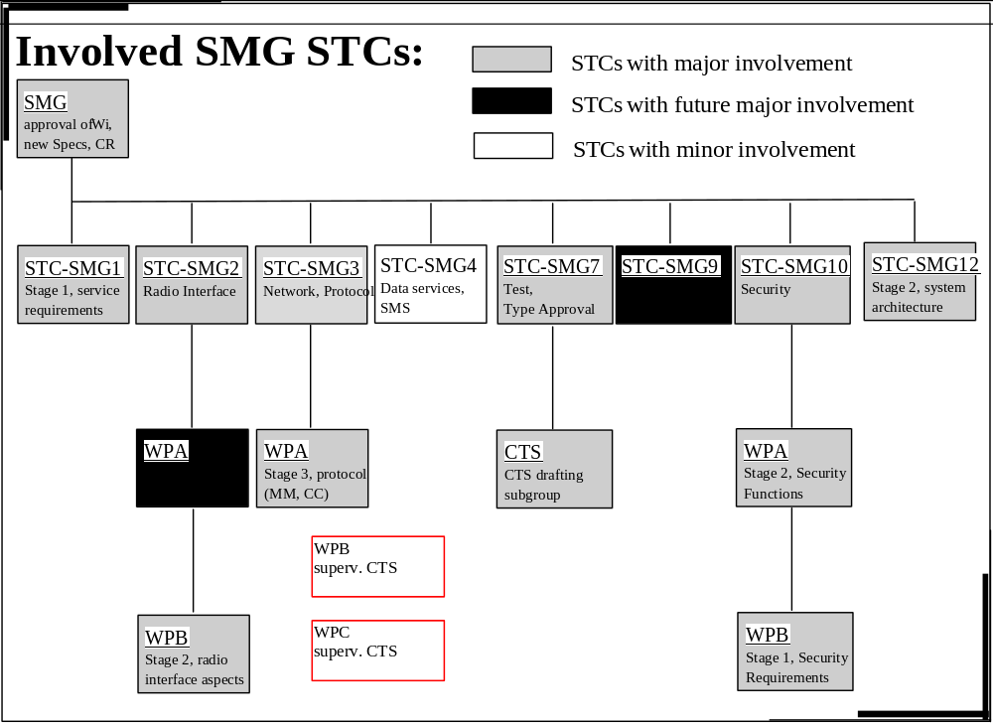

CTS phase 1 overall schedule

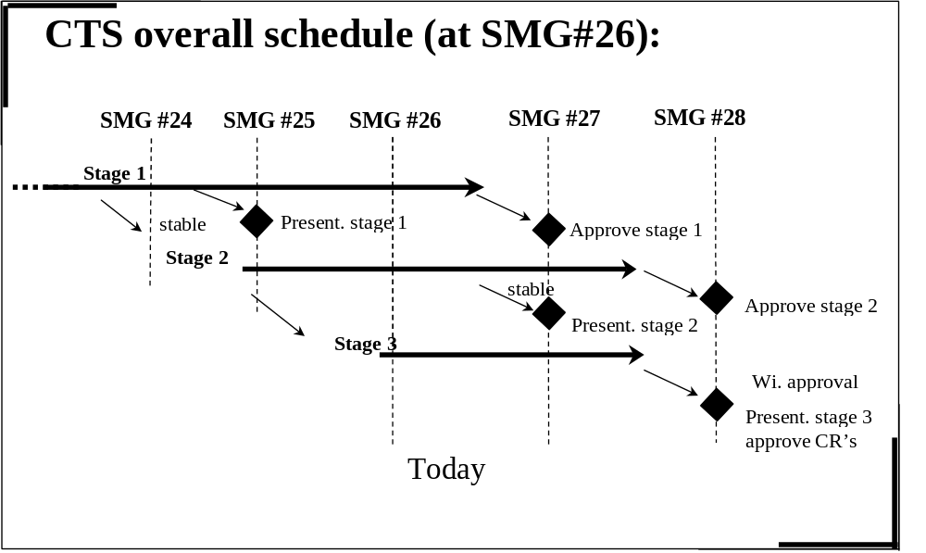

CTS phase 1 schedule from SMG#26to SMG#27

CTS stage 1
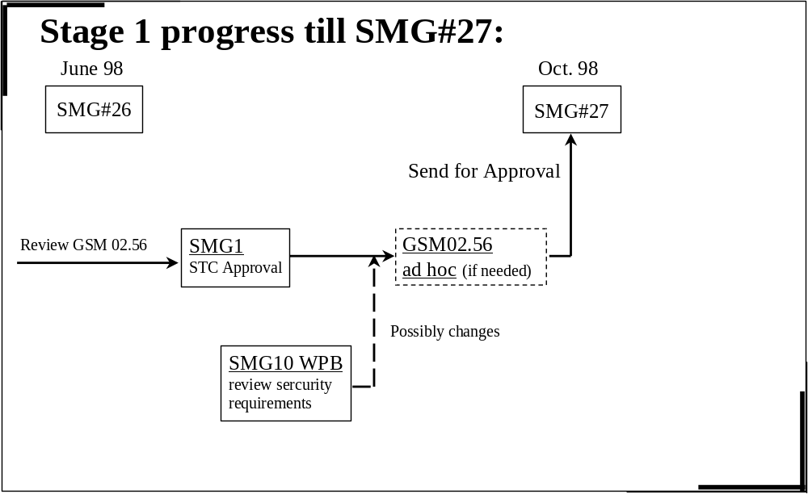

CTS stage 2
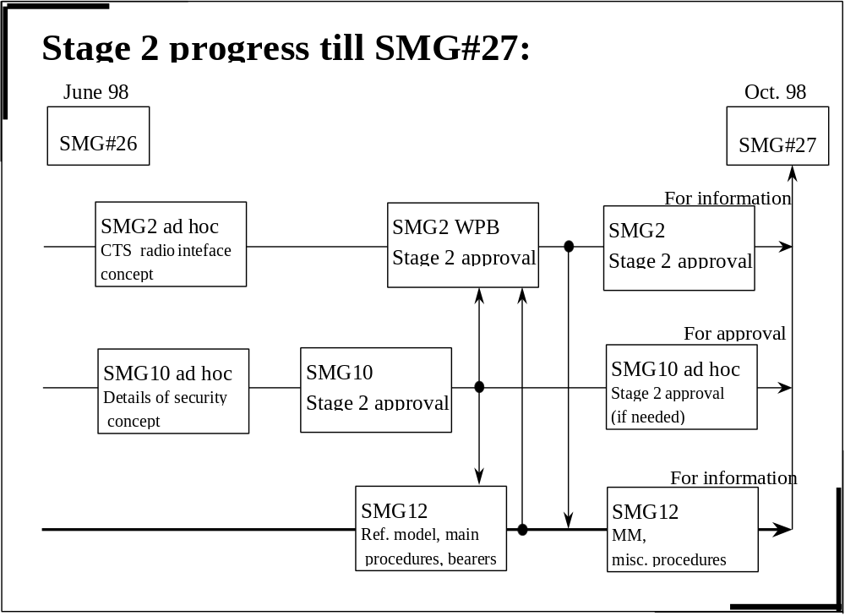

CTS stage 3
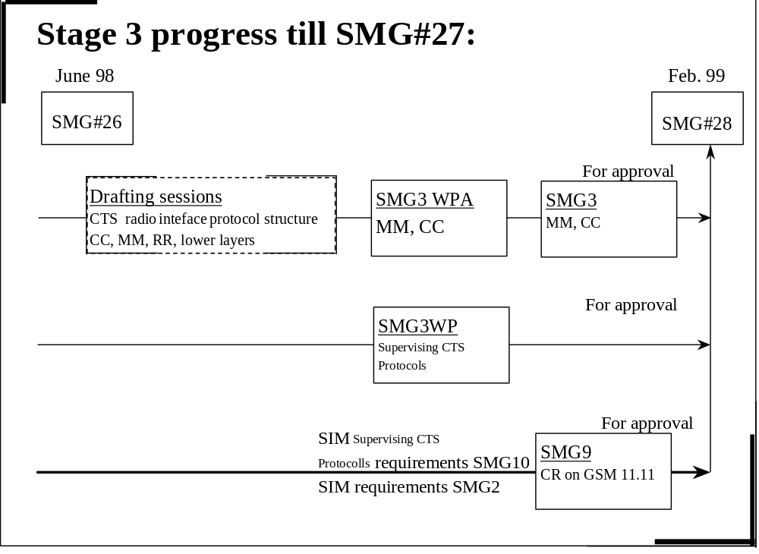

CTS stage 3
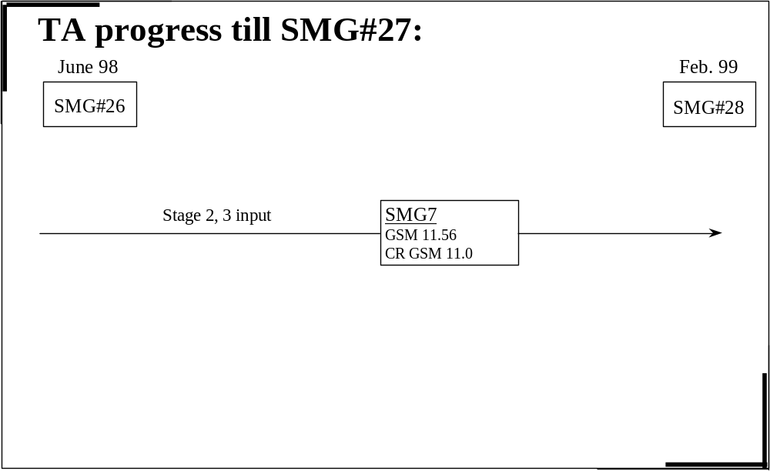

History
Document history
Note: Explicit changes in this document are not shown with revision marks
1998- 02 | Version 0.0.1 first presented at SMG10 plenary 4-6.2.1998
1998-02 | Version 0.0.2 after SMG10 plenary and input for SMG 2 plenary 23 - 27.3.98
1998-03 | Version 1.0.0 for presentation at SMG#25
1998-03 | Version 1.0.1 included new chapter for open issues of the CTS stage 2 definition  (Prepared at the SMG12 meeting 23.-27.3.98 in Bad Aibling)
1998-04 | Version 1.1.0 at SMG10 plenary 6.4. - 9.4.98 in Lund
1998-05 | Version 2.0.0 at the SMG plenary, #26
1998-08 | Version 2.0.1 : after SMG#26 and input for SMG3WPA 25-28/08/98
2000-02 | Version 7.0.0
2000-03 | Version 8.0.0
Rapporteur: Michel Galligo
Email: michel.galligo@bsf.alcatel.fr

